Requirements Document

WaveSSounds Project

1. **Goals**

The goal of this project is to create a music streaming app using a JavaScript Framework and Java backend. Initially, the common functionalities design will be created, followed by their implementation. The app should be able to post new songs and to show them to the other users.

1. **User Personas**
2. User
3. Artist
4. Admin
5. **User Stories**

**Using MoSCoW prioritization:**

**M(Must have):**

1. As a user, I want to be able to listen to the songs that I like, so I could fill my time.
2. As a user, I want to be able to add songs to a favorite list, so I can mark my favorite ones.
3. As an artist, I want to be able to create an account, so I could upload new content.
4. As an artist, I want to be able to change my page, so I can update the content.
5. As a user, I want to be able to give authorization to another account, so it can make changes to my page(playlists, liked songs, etc.)
6. As a user, I want to be able to see songs filtered by year/genres/artist, so I could easily find anything.
7. As a user, I want to be able to use a search bar to find the song/album/artist that I want.

**o**

**S(Should have)**

1. As a user, I want to be able to see some new releases when I get on the app, so I can find new things to listen.
2. As a user, I want to create my own playlists, so I can pick up specific songs in one place.
3. As a user, I want to be able to see informations about a song/artist, so I can stay informed about news.
4. As an artist, I want to be able to post new content, so I can share new things.
5. As an artist, I want to be able to delete content, so I can fix mistakes.
6. As an artist, I want to modifiy content (e.g. change the information about him as an artist or to change information about a song), so I could easily update information.

**C(Could have)**

1. As a user, I want to have some radios with different types of music, so I can listen when I don’t know what.
2. As a user, I want to be able to see informations about a song/artist, so I can stay informed about news.
3. As a user, I want to be able to follow artists, so I can stay in touch with their feed.
4. As a user, I want to be able to add songs to the queue, so I could make a little playlist while listening.
5. As a user I want to be able to shuffle/repeat a playlist or the queue, so I won’t care about the order.

**o**

**W(Won’t have, this time)**

1. As a user, I want to have transitions between songs, so there is no pause.
2. **Sitemap**

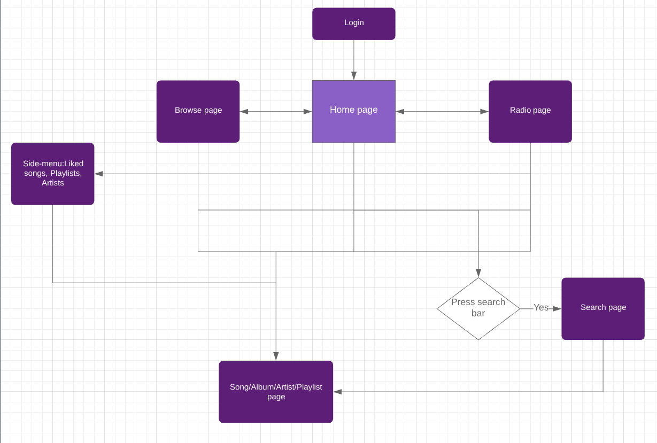

1. **Page Descriptions**

|  |  |
| --- | --- |
| Page | Elements |
| Homepage | 1.Search bar  2.Main side menu: Home, Browse, Radio  3.Secondary side menu: Liked songs, Artists, Playlists  4.Grid zone with content  5.Music player below  6. Account settings  1,2,3,5,6 – General(On all pages) |
| Browse page | 1.General  2.Multiple tabs with sorted content on categories |
| Radio page | 1.General  2.Grid zone with different radios |
| Search page | 1.General  2.List with recent searched items |
| Song/Album/Artist/Playlist Page | 1.General  2.Artist picture and name  3.List with the content  4. More like the “artist” |

1. **Wireframes (optional)**

**To be completed…**

1. **Non-Functional Requirements**
2. **Java backend**
3. **JavaScript Framework**
4. **A user account which uses the content**
5. **An artist account which makes the content**
6. **Risks**
7. **Technical problems**
8. **Failing this semester**
9. **Future Iterations**